Assignment 4.4

1. Write a Java program to copy a file from HDFS to LFS

Code:

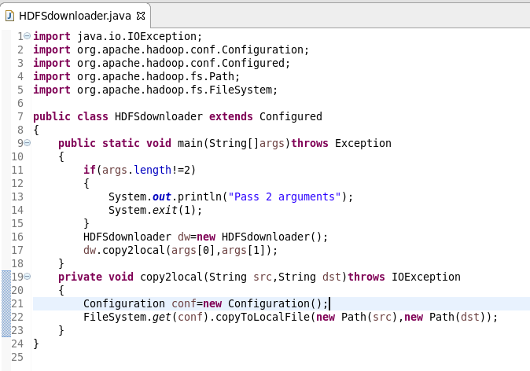

Output:

